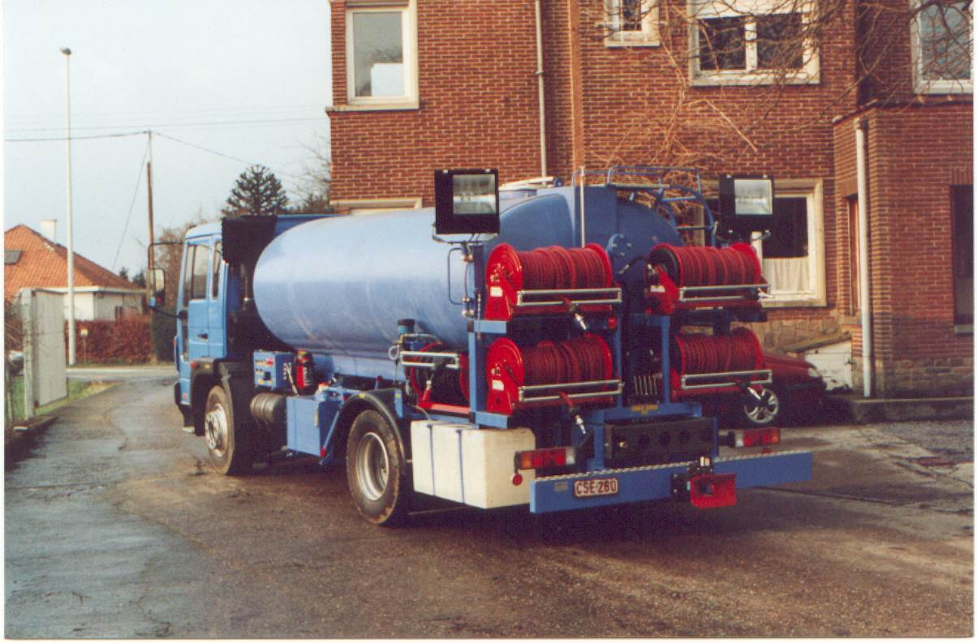
Aircraft washing truck

Specifications:
- Basic vehicle: Volvo FL 6.14 or similar with PTO
- Polyester water tank: 8 000 litres
- Poly urethane soap tank: 200 litres
- Hydraulic system build with Rexroth components
- Hydraulic driven water pump and auxiliary systems simultaneously.
- Bypass system with heat exchanger to avoid overheating of water pump and hydraulic system.
- 5 hydraulic hose reels with 80 metres of hose each.
- Oversized 7-stage centrifugal water pump with a capacity of 360 litres/minute at 18.2 bar, thanks to this configuration there will be hardly any pressure difference when using one or 5 hoses.
- Water activated adjustable soap injector
- Work area lightning by 2 adjustable high performance HQI lights
- 220 Volts supply by a reinforced 24 Volts alternator, combined with a 220 Volts sinusoid inverter of 2 500 Watt.
- Stair to the stainless steel hatch for refilling and cleaning of the tank.
- CE approved
- 2 year warranty on parts

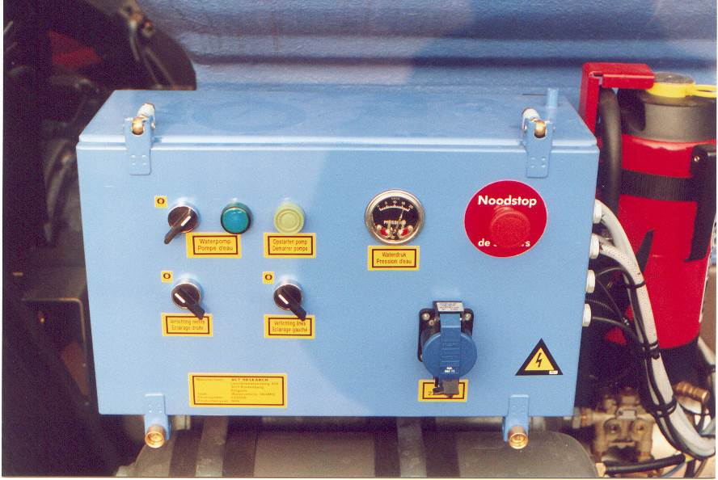

Options
- Extra valves for outboard hydraulic appliances
- Hydraulic soap dispenser
- Construction to customer specification

